Computer Science
Introduction
Saved 2022-02-18

An introduction to the intellectual enterprises of computer science and the art of programming

rev 1.9

Contents
1 Overview 3
1.1 What is a computer? 3
1.1.1 Data? What are data? 3
1.1.2 Data Processing 4
1.1.3 Programmable Devices 5
1.1.4 Computer Software 6
1.1.5 Surprise 7
1.2 Basic Computer Science 7
1.2.1 Foundations 8
1.2.2 Computer Networking 8
1.2.3 Computer Graphics 8
1.2.4 Scripting Languages 8
1.2.5 Developing Software for Desktop Devices 9
1.2.6 Developing for the Web 9
1.2.7 Developing Software for Mobile Devices 9
1.2.8 Embedded Device Programming 9
1.2.9 Cross-Platform Development 9
1.3 Managing Software Projects 9
1.4 Advanced Computer Science 9
2 Digital Technology 11
2.1 Number Systems 11
2.2 Boolean Algebra 13
2.2.1 Basic Computation Rules 13
2.2.2 Logic Expressions 14
2.2.3 More Counting Rules 15
2.2.4 Alternative Representations 16
2.2.5 Logic Simplification 19
2.3 Combinatorial Networks 20
2.3.1 Multiple output signals 22
2.3.2 Sequential Networks 22
2.4 Designing Logic Circuits 29
2.4.1 Designing Combinatorial Logic 29
2.4.2 Applications of Combinatorial Logic 30
2.4.3 Designing Sequential Logic 32
2.4.4 Applications of Sequential Logic 33
3 Programming concepts 47
3.1 Computer Architecture 48
3.1.1 Central Processing Unit 48
3.1.2 Random Access Memory 48
3.1.3 Buses 48
3.1.4 IO Ports 48
3.1.5 Peripheral Devices 48
3.2 Programming the 6502 microprocessor 48
3.3 Programming the 8086 microprocessor 48

Overview

Nowadays, computers are part of our everyday life. We use personal computers at home and at the office, we carry laptops, tablets and mobile phones, which all are essentially computers. We have computers embedded in our cars, our TV set, and even in our washing machine. So what exactly are computers?

What is a computer?
A computer is a device that can process data. Uhum..

Data? What are data?
Well.. ..when we sit in a coffee-shop and gossip about our common friends' latest romances, then we orally exchange data. This data may or not contain any useful information.

This data flows from someone's output device ( her mouth ) to others' input devices ( their ears ), and the medium that carries the data is thin air, and the data is encoded as words of some natural language, e.g. English.

It can be so, that the data that reaches Kathy's ears (her input device) carries a lot of information to her, as she previously had no idea about that Peter left Marie for Eve. John, who is also one of the recipients of the same data, finds the whole issue boring. It contains no information to him, as he already heard the story from Peter, first hand.

Okay, nice. So what does gossiping in a coffee-shop has to do with information, data, and computers?

Well, from the above example we can see, that data, as such, is something objective. That is, it exists by itself. Data (plural form of datum) can be created, it can be transmitted, and it can be stored.

Data has these characteristics:
- Data are encoded. This means we use some code ( e.g. English language ) which is already commonly understood to express data.
- Data can be stored on a storage medium and it can be transmitted through a communications medium from a sender to one or more recipients.
- Data exists objectively as the state of the medium that bears the data.
Data is not information. Data may carry information to some however. Information is subjective. Information needs both a sender and a receiver that understands that information.

For example, if there is no receiver ( e.g. nobody hears you talking ) , there is no information, while the sender still produces data.

Information, to exist, also requires that the sender and the receiver(s) use the same encoding.

For example if one talks Chinese and the recipient (listener) understands English only, no information will be conveyed.

So again, what do computers do?
Computers process data.
They don't process information, since information as such is subjective to the listener(s) , they process data, which is objective, and it exists as the encoded state of some bearer medium.

Data Processing
Data can be also altered and transformed of course. (That sounds familiar, when it comes to gossiping, right? ☺) Professionals call altering and transformation of data for data processing.

Yes OK. Computers process data. So what do computers exactly do?

Computers take in some data (data input), they may process it (alter it, transform it), they may output data, or they may store the data for later processing or for later output.

Data input and output
Computers may receive data from humans or from other computers. They also can send data to humans or to other computers.

Humans may use input devices, such as a keyboard, a mouse, or a touch screen to input data into a computer. Display screens and printer devices are usually used as output devices. Such input and output devices are called human interface devices (HID).

Computers may send data to and may receive data from other computers as well, through some interconnection. Multiple interconnected computers form a computer network that use specialized communication ports (rather than display screens, mice and keyboards) to communicate with each other. We'll discuss computer networks in more detail later on.

Communication Protocols - The Language of Computers

The Language of Humans
Humans usually use some natural language, such as English or maybe some sign language, to communicate. Non-verbal communication still has a significant proportion as a method of communication. The communication medium can vary. It is the thin air carrying sound waves when people talk to each other directly. We also can communicate in writing, by leaving bills to each other, writing books, newspaper articles, or by street signs. Nowadays we also use electronic media. We publish blogs, upload videos to YouTube, or chat trough Viber, just to name a few possibilities. Human communication can be complex. We can enhance our verbal messages with illustrations, moving pictures (videos) or sounds (e.g. music). Sometimes, the illustration itself, or the instrumental music is the message, lacking any verbal component.

The Language of Computers

Communication Protocols are the language of computers.
By contrast computers use much simpler means of communication than humans do. Computers do not usually communicate in human sense, that is, they do not exchange information, since they typically do not understand the data they process. Computer communication is usually mere data exchange.

For example, the Internet is a huge network of computers. One of the protocols used on the internet is HTTP, the HyperText Transfer Protocol.
The interaction between computers needs some kind of common language. The languages computers use among each other we call communication protocols.

Our favorite web browser uses HTTP to request web pages from web servers. The web browser is said to be the HTTP client, and the web server is the HTTP server. This is a typical example of client-server communication. The client sends a request and the server replies with a response.

HTTP is not the only protocol used on the Internet. When we exchange e-mail messages, for example, the SMTP ( Simple Mail Transfer Protocol ) is used. Yet other protocols are used to transfer files (FTP – File Transfer Protocol), to stream videos (RTSP), and so on. More on this later.

Recap
- All communication (data exchange) among computers and humans likewise, require a communications medium capable of carrying data encoded in some commonly understood format.
- People typically use natural languages to communicate among each other and use formal languages to communicate with computers.
- Computers use communication protocols to communicate with each other and produce all kinds of audio, visual or textual output for humans to look at, listen to or read.
- Data may be stored on a storage medium for later reuse.
- Data exists as the state of some communications medium or storage medium.

At the most basic level, the state of data is encoded as a sequence of binary values in digital computers. That is, a sequence of zeroes and ones are used for representing numbers, letters, written text, and even computer programs. A sequence of binary values can be stored or transmitted using some communications medium or storage medium.

We will start with understanding how to use binary values to represent logic values, numbers, letters, text, pictures, video, music, and even computer instructions.

Programmable Devices
Computers compute, right? Well, partly. Computers compute (that is, they process data), exchange data (with humans or other computers), and they store data for later reuse. So the term computer is actually a misnomer as it does not accurately reflect what that thing we call computer is actually able to do. Nowadays we prefer talking about programmable devices.

There are general purpose programmable devices in various sizes, which we colloquially call computers. But there are also special purpose programmable devices, which were designed with specific applications in mind. For example a mobile phone is a special purpose programmable device. Also the microcontroller that supervises certain functions of a car, such as the break system or the cruise control, is also a programmable device. You'll find programmable devices in household appliances, industrial machines, vehicles, and robots.
Any device that is capable of running (executing) a computer program is a programmable device.

When we talk about computers, we usually refer to general purpose devices, such as PCs ( Personal Computers), or bigger mini-computers, or the biggest mainframe computers. PCs are considered micro-computers.

OK, so computers are general purpose programmable devices. What does that mean?

Well, the metal part of a programmable device, also called the hardware has no predefined behavior. Its behavior is defined by a so called program, also called the software.

From a user perspective, software is that really matters, because the software defines the behavior of hardware. The hardware only provides the medium for executing the software. The hardware is the body, and the software is the soul. The soul needs a body to exist. Indeed, some souls, I mean software are capable of running on different types of hardware, and they make different types of hardware to behave similarly.

For example, one could run the same computer game on PCs, Apple, or Xbox and ave the same experience. The text processor Microsoft Word runs on PCs, Apple computers, or even on Android devices. On all those platforms, Microsoft Word does the same: It make possible for the user to edit documents containing text and pictures.

Software tells computers how to process data.

So what does the hardware do?

The hardware reads a program and executes it. One instruction after the other. A program consists of a bunch of elementary instructions that the computer's CPU ( central processing unit) can understand and execute. Example instructions are arithmetic instructions ( add, subtract, divide, multiply), input/output (I/O) instructions ( read, write ), or program control instructions ( halt execution, jump to some other part of the program and continue execution from there, call a subroutine, and more). More on this later on, when we'll discuss assembly level programming.

Computer Software
Computer software is a special kind of data that the computer's central processing unit (CPU) interprets as a set of instructions (basic operations) to be performed on some other data.

Computer programs are a set of instructions that tell the CPU what to do. When the CPU executes a program, the CPU reads the instructions within a program and performs the operations as instructed by the program.

When the CPU executes a program, it does data processing. So data processing is nothing else but a set of operations performed on some data by some CPU as instructed by some software program.

Operations? What's that?
Well, there are various operations CPUs can perform. The exact set of operations CPUs can perform, and how they perform it, depends on the CPU brand, but there is a common set of operations all CPUs can do in some form. These are:

- Arithmetic operations ( + - / * )
- Logical operations ( AND OR NOT )
- Comparisons ( < <= = <> => > )
- Jumps: Normally instructions are executed in sequence, one after the other. A jump instruction tells the CPU to jump forward or jump backwards within the program code, and continue from there, rather than taking the next instruction that normally would follow.
- Conditional jumps: Same as above, but the jump is executed only if some condition is true. For example, the operation 'jump if zero' is executed only if the operand of that instruction is zero. If the operand in not zero, then the jump is not executed and processing will continue at the next instruction in sequence.

Surprise
I hope you enjoyed reading all the above and you understood it and memorized it well. Now comes the surprise: many of my previous statements are not true.

We can say, they are true for some computers, and they were true once upon a time, but thing is, computer science and technology keeps evolving at an accelerating rate, and both hardware and software becomes more and more capable and more and more complex.

Nevertheless, we need to start with simple things in order to be able to tackle more complex hardware and software engineering issues in the future.

So what exactly is not true, huh? Well, here are some things, that changed over time:

- The CPU executes one instruction at a time in sequential order. Nope. Modern processors are capable of executing multiple instructions in parallel. Whenever there is a jump in the code, they execute both possibilities ( both branches of the code ) and later at some point they will throw away the 'bad branch' and keep executing the 'good' branch.
- A computer has a single CPU that understands the program code and executes it. Nope. A modern computer can have multiple so called cores. Each core is a full-fledged CPU. So a modern computer can have multiple threads of execution, not just one. As you might imagine, writing multi-threaded programs is far more complex then writing single-threaded programs. A good analogy is cooking recipes. Imagine we want to prepare pork chops with mashed potatoes and salad. If we think 'single-threaded', then first we prepare the pork chops, then the potatoes, and finally the salad. However, it would be more efficient to peel the potatoes while the pork chops are frying, then let the potatoes boiling before the pork chops are ready, and while both items are on the oven we could prepare the salad. This would be the multi-threaded style of cooking, since we maintained multiple 'threads of execution', namely frying the pork-chops, boiling the potatoes and preparing the salad all happened in parallel.
- It's getting worse. Even a single core (CPU) can do multi-threading. Well, this is not true parallel multi-threading, since we still have a single execution unit, which can do only one thing at a time, but for us humans apparently multiple threads are running. The trick is, that the CPU ( actually the programmer who wrote the program) starts multiple threads, and the CPU cycles through all these threads and executes only a few instructions of each, then goes to the next thread, where it executes a few instructions, then to the next, and so on. Since this kind of thread switching occurs very fast, for us humans it looks like multiple threads are running at the same time.
- It's getting even more worse. Not only the CPU can execute software code. The GPU can do that too. ..and typically there are multiple GPUs , like 1024 pieces of them. What GPUs are, we'll find out later when we discuss so called HPC (High Performance Computing).
- Not just the hardware, but the software is evolving. We said, that computers just do data exchange, because they understand nothing, just compute blindly and do exactly what are instructed to do. Well, this is not entirely true anymore. Some types of software can actually learn things, they can be trained to recognize things, they can even become experts in some domain or the other. For example, the so called recommender systems give advice to politicians or help medical doctors diagnose diseases based on symptoms, plus they recommend medication. These systems are far more reliable than human beings, because they can process huge amounts of data much faster, than humans can do, they have practically endless memory capacity, and they have the ability of flawless reasoning.

We'll start with simple things. The goal is to acquire enough knowledge so that we can contribute to the evolution of software.

Basic Computer Science
According to Wikipedia, Computer Science is the study of processes that interact with data and that can be represented as data in the form of computer software. It enables the use of algorithms to manipulate, store and communicate digital information.

A computer scientist studies the theory of computation and the practice of creating software systems.

This write-up aims to cover key topics in computer science so that the reader can make practical use of it. This is what you'll learn:

- A broad and robust understanding of computer science and programming
- How to think algorithmically and solve programming problems efficiently
- Concepts like abstraction, algorithms, data structures, encapsulation, resource management, security, software engineering, and web development
- Familiarity in a number of programming languages, including C, and C++
- How to engage and collaborate with a community of like-minded peers from all levels of experience
- How to develop and present a programming project to your peers and to your customers

First, we'll go through the foundations. Then we'll cover the basics of programming, we'll learn basic algorithms, about programming models, essential workflows, and how to organize our work.

Then, we'll go deeper in selected software engineering topics. We'll learn about databases, computer networks, different application types, source code management, and basic project management.

Then we'll touch the currently hottest topics in computer science, including machine learning, computer vision, data mining, cloud computing, internet of things, autonomous agents, and bioinformatics.

The last step will be a software development project that will require usage most of the ( cold ☺ ) topics covered.

Foundations
- Digital Technology
- Programming concepts. Assembly level programming. Embedded Applications.
- Programming languages, compilers, interpreters, linkers.
- Structured Programming. The C Programming language and it's applications
- Object Oriented Programming. The C++ Programming Language.
- Algorithms and Data Structures
- Operating system concepts

Computer Networking
- Data Exchange Technologies
- Communication Protocols
- Computer Networks
- Scalability Models

Computer Graphics
- Computational Geometry
- Writing CG Applications
- Game programming

Scripting Languages
- JavaScript
- Python

Developing Software for Desktop Devices
- Command Line Applications
- Event Driven GUI Applications
- Multithreading
- Networking with TCP/IP
- Writing Server Applications

Developing for the Web
- HTML and CSS
- Writing Web Applications

Developing Software for Mobile Devices
- Native Applications
- HTML Applications
- Hybrid Applications
- Using the Android NDK

Embedded Device Programming
- Introduction to Embedded Devices
- Real-time programming concepts
- Programming the Raspberry Pi
- Programming the Arduino
- Programming the NVIDIA Jetson

Cross-Platform Development
- Popular Operating Platforms
- The Windows Operating System
- The Linux Operating System
- Cross-Platform Tools and Libraries
- Programming Qt in C++

Managing Software Projects
- Source Code Management
- Issue Management
- Teamwork and Collaboration Software
- Introduction to Project Management

Advanced Computer Science
- Mathematical Foundations
- Data Modeling
- Parallel Programming
- Distributed Computing
- Computer Security Concepts
- Cryptography
- Software Engineering, Architecture, and Design
- Automated Reasoning and Verification
- Data Analytics
- Language Processing
- Formal Languages – Compiler Technology
- Natural Language Processing (NLP)
- Foundations of Machine Learning
- Foundations of Computer Vision
- Foundations of Robotics ( Autonomous Machines )
- Principles of Digital Biology

Digital Technology

The first attempts to construct computers faced a basic problem: How to represent numbers and arithmetic operations? That is, if we want to have a machine add two numbers, then we have to represent those numbers and the 'addition' operation somehow. We also need a way to 'tell' the computer what numbers we would like to add, and read the result.

Someone thought numbers could be represented by voltages. One would represent the values 0,1,2,3,4,5,6,7,9 with 0V, 1V, and so on. This way numbers 0 to 9 would correspond to the voltage in some wire. Assuming a decimal number system, multi-digit numbers would require multiple wires.

Well, there were actual computers using the above approach, but it quickly turned out, that this approach is problematic. The output voltages as a result of arithmetic operations were not accurate enough. It worked well for simple cases, but formulas involving tens of operations the output voltage became totally unreliable.

So what should we do? On thing is for sure: the output voltage might be inaccurate, but the fact that there is voltage or not, can be detected precisely. Tadaa..

Some clever dude came up with the idea to use the binary number system in computers, rather than the decimal, since binary numbers have only two values 0 or 1, which can be easily and accurately represented by two electrical states: "there is voltage"=1 and "there is no voltage"=0. The exact value of the voltage level thus became unimportant.

Today, all computers use zeroes and ones to represent everything, numbers, codes, text, and graphics. This is why we'll look into number systems and the binary number system, in particular, and its uses.

Number Systems
Let's start with our number system we use. We use a positional number system with base 10. We call it positional, since the position of digits within a number have significance. The position represents a value in the following way:

For example, the number 123 ( one hundred twenty three ) consists of three digits. Three ones, two tens, and one hundred. That is, 123 = 1*100+2*10+3*1. We could also write it like this: 123 = 1*10² + 2*10¹ + 3*10⁰. We see, that the 3 on position 0 represent ones ( because 10⁰ = 1 ) , the 2 on position 1 represents tens ( because 10¹ = 10 ), and the 1 on position 2 represents hundreds ( because 10² = 10*10 = 100 ).

10^{n} represents the exponentiation operation. 10^{n} says 'multiply 10 with itself n times'. Thus 10³=10*10*10, 10⁴=10*10*10*10, and so on. The 10 is the base. That's why we call our number system a positional number system with base 10.

If we were to use 2 instead of 10 as base, we'd get a binary positional number system.

Actually any positive integer could be used as base. Other common number systems used in computer science are the octal system, that uses 8 as base, and the hexadecimal number system that uses 16 as base.

The number of digits necessary to represent any number in a given number system equals to the base. The decimal number system uses 10 digits ( 0,1,2,3,4,5,6,7,9 ), the binary number system uses two digits ( 0, 1 ), the octal number system uses eight digits ( 0,1,2,3,4,5,6,7) and the hexadecimal number system uses 16 digits ( 0,1,2,3,4,5,6,7,8,9,A,B,C,D,E,F ).

The reason we use octal and hexadecimal number systems (in writing only ) is that they are much more easily readable, than binary values. Binary numbers are long to write, while the corresponding hexadecimal number is compact. For example:

7DA₁₆ = 011111011010₂ = 3732₈ = 2010₁₀

The subscript indicates the base. For the decimal system we usually omit indicating the base, since 10 is the default base. Another way to write the above is:

7DA_{H} = 011111011010_{B} = 3732_{O} = 2010

Okay, so why the fuss with hexadecimal and octal numbers? Why not just simply use decimal numbers in writing? Well, because binary numbers can be converted easily to hexadecimal or octal numbers. Try to convert a binary number to decimal, and you'll see what I mean.

To convert a binary number to hexadecimal, simply group the binary digits ( bits ) into groups of four, from right to left. Then convert each group. For example:

011111011010₂ = 0111 1101 1010₂ = 7DA₁₆ , since

0000_{B} = 0_{H}
0001_{B} = 1_{H}
0010_{B} = 2_{H}
0011_{B} = 3_{H}
0100_{B} = 4_{H}
0101_{B} = 5_{H}
0110_{B} = 6_{H}
0111_{B} = 7_{H}
1000_{B} = 8_{H}
1001_{B} = 9_{H}
1010_{B} = A_{H}
1011_{B} = B_{H}
1100_{B} = C_{H}
1101_{B} = D_{H}
1110_{B} = E_{H}
1111_{B} = F_{H}

To convert a binary number to octal works the same, except we groups of three bit instead:

011111011010₂ = 011 111 011 010₂ = 3732₈ , since

0000_{B} = 0_{O}
0001_{B} = 1_{O}
0010_{B} = 2_{O}
0011_{B} = 3_{O}
0100_{B} = 4_{O}
0101_{B} = 5_{O}
0110_{B} = 6_{O}
0111_{B} = 7_{O}

Now let's try to convert 011111011010₂ to decimal. To do that we’ll need to use the formal definition of the binary numbers, and calculate the decimal value. ( We could use the same procedure for hexadecimal and octal numbers, or for any base in fact, but for hexadecimal and octal numbers we've found smart shortcut methods, that save us time and brainpower. )

011111011010₂ = 1*2¹⁰+1*2⁹+1*2⁸+1*2⁷+1*2⁶+0*2⁵+1*2⁴+1*2³+0*2²+1*2¹+0*2⁰ =
= 1*1024+1*512+1*256+1*128+1*64+0*32+1*16+1*8+0*4+1*2+0*1 =
= 1024+512+256+128+64+16+8+2 = 2010

Voilà.

Question: How could we convert a number from decimal representation to binary?

Boolean Algebra
Boolean Algebra is the algebra of mathematical (formal) logic. It is named after George Boole, a mathematician from the 18th century. (Algebra is a part of mathematics dealing with formulas.)

Boolean Algebra is a very useful thing, as it represents the theoretical foundation of digital technology. It is applied, when designing digital electronic circuits, and also it is fundamental to software programming. Boolean algebra knowledge is essential, for example, when designing or implementing cryptographic methods. We'll discuss cryptography later on.

The most important property of Boolean Algebra is that it operates on two-valued entities. These two-valued entities may represent logic values ( true, false ) or binary digits ( 0, 1 ).

Boolean Algebra has three basic operators: AND, OR, NOT. These are the logical operators. In this document we will use the following symbols to represent logical operators:

AND: & infix operator, for example: 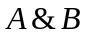, or *, for example: 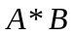. It reads: A AND B.
OR: | infix operator. for example 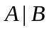, or +, for example: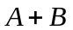. It reads: A OR B.
NOT: ! prefix. For example: , or overline, for example 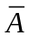.

Please note, that the symbol * in the above context means AND, and it does not mean multiplication. Also, the symbol + means OR, and not addition.

By contrast, "usual" algebra operates on integers, real values, complex values, or other sets. It has four basic operators: +, -, /, *, also called the arithmetic operators.

For example, A+B=C is an algebraic expression, Y = X²+2 is another algebraic expression. If we restrict the possible values of A, B, X, and Y in the above expressions to 0 and 1 or to True/False, then the above expressions could be interpreted as Boolean expressions.

Basic Computation Rules
In Boolean Algebra we have three operators, *.+, and ! ( AND, OR, NOT ). How do they work? For example 1+0=?

We already know how to do arithmetics, for example 1+1=2, or A+B=C, where A=1, B=1, and consequently C=2.

Good news: The rule for how the addition operator works in arithmetics is fairly complex compared with how logical operators work on two-valued entities. Logical operators, in fact, are so simple, that they can be expressed in table form, by using so called truth tables. We'll now define the three basic logical operators using truth tables:

AND operation
The AND operation in formal logic is similar to multiplication in arithmetics, but much simpler. For example, 0*0=0, 1*0=0,0*1=0, and 1*1=1. This is true in both arithmetics and in formal logic. The big difference is, that in arithmetics we also have 12*3=36, 2*4=8, and an infinite number of more possible combinations. However, in Boolean algebra, that's all we have: 0*0=0, 1*0=0,0*1=0, and 1*1=1 That's it. This we can express with a truth table:

A | B | A&B
0 | 0 | 0
0 | 1 | 0
1 | 0 | 0
1 | 1 | 1
Table 1 - AND Operator

By comparison, if we were to produce a truth table for any arithmetic operator, that table would have an infinite² number of rows, which is unfeasible.

OR operation
The OR operation in Boolean algebra resembles addition in arithmetics, but it must not be confused with addition. The OR operations is also much simpler, than arithmetic addition. The OR operation is defined by the following truth table:

A | B | A+B
0 | 0 | 0
0 | 1 | 1
1 | 0 | 1
1 | 1 | 1
Table 2 - OR Operation

NOT operation
The NOT operation is even simpler, because it is an unary operation. That it, it takes only a single operand. The OR and AND operators have two operands, just like addition and multiplication in arithmetics. The NOT operator takes only a single argument and negates its value. (In arithmetics we have the unary operator -, which we use to express negative numbers, for example -1, -12.) The truth table for the NOT operations is:

A | !A
0 | 1
1 | 0
Table 3 - NOT Operation

Logic Expressions
When calculating logical expressions, we have to consider operator priority, just like in the case of arithmetic expressions. For example, we know that 4+12*3=40, because we calculate multiplication before addition. Likewise, in boolean algebra the operators have priorities.

The NOT operator has the highest priority, followed by AND, and then by OR.

So, in a logical expression the NOT operations are calculated first, the AND operations, and finally the OR operations.

Example:
Consider the following expression: A+B*!C=D.
Now let A=1, B=1, and C=0. What will the value of D be? It will be 1. Order of calculation:

Step 1: !C=1, because C=0
Step 2: B*!C=1*1, because B=1
Step 3: B*!C==1, because 1*1=1 according to the truth table of the AND operator above
Step 4: A+B*!C=1+1, because A=1
Step 5: A+B*!C==1, because 1+1=1 according to the truth table of the OR operator above

So 1+1*!0=1 .

The order of operators can be modified by using parenthesis, just like in arithmetics.
Examples:

(A+B)*C
!(A+B)+C*(D+E)
A+!(B*(C+D))

Question: Can you tell the correct order of operators?

More Counting Rules
Herein we’ll go through some formulas that ease counting with boolean expressions. These formulas all follow from the basic definitions of the logic operators, as described in section 2.2.1 above.

- AND and OR are commutative.
That is, A*B = B*A, and A+B=B+A.

This can be easily verified, by comparing the truth tables for A*B and B*A. For A*B we have:

A | B | A&B
0 | 0 | 0
0 | 1 | 0
1 | 0 | 0
1 | 1 | 1

Now if we swap columns A and B and fill out the third column based on the original truth table, we get:

B | A | B&A
0 | 0 | 0
1 | 0 | 0
0 | 1 | 0
1 | 1 | 1

For both tables, the third column looks the same, so A*B = B*A.

You can verify similarly, that A+B=B+A.

- AND and OR are associative.
That is, (A+B)+C = A+(B+C), and (A*B)*C=A*(B*C).

This fact can also be verified, using the truth table:

  A | B | C | A&B | (A&B)&C
  0 | 0 | 0 | 0 | 0
  0 | 1 | 0 | 0 | 0
  1 | 0 | 0 | 0 | 0
  1 | 1 | 0 | 1 | 0
  0 | 0 | 1 | 0 | 0
  0 | 1 | 1 | 0 | 0
  1 | 0 | 1 | 0 | 0
  1 | 1 | 1 | 1 | 1
  A | B | C | B&C | A&(B&C)
  0 | 0 | 0 | 0 | 0
  0 | 1 | 0 | 0 | 0
  1 | 0 | 0 | 0 | 0
  1 | 1 | 0 | 0 | 0
  0 | 0 | 1 | 0 | 0
  0 | 1 | 1 | 1 | 0
  1 | 0 | 1 | 0 | 0
  1 | 1 | 1 | 1 | 1

For both tables, the third column looks the same.

- AND is distributive wrt OR.
That is, A*(B+C) = A*B+A*C.

Verify the distributive property!

We saw, that the commutative, associative, and distributive rules apply in Boolean algebra, just like they apply in arithmetics.

- De-Morgan laws:
!A*!B=!(A+B)
!A+!B=!(A*B)

Verify the De-Morgan laws using the truth tables for AND, OR, and NOT!

Some additional laws, that help calculations:

- Annulment: A*0=0, A+1=1
- Identity: A*1=A, A+0=0
- Idempotency: A*A=A, A+A=A
- Complement: A*!A=0, A+!A=1
- Double Negation: !!A=A
- Absorption: A*(A+B) = A, A+A*B=A

Alternative Representations
We already used two ways to represent logical relationships:
- Function/Expression notation, e.g. Y=A+B*C
- Truth table

A third common way to represent logical relationships is by representing logic operators as 'logic gates'. This is a natural way for those constructing digital electronic circuits.

- Circuit diagram

Logic Expressions
The same logical relationships can be expressed in multiple equivalent ways. For example A*(B+C) is the same as A*B+A*C. The latter looks like a "sum of products", or more precisely a disjunction of conjunctions. This form is also called the conjunctive normal form (CNF).

Any logic expression can be written in CNF. Using this representation has practical benefits. One such is that each "term" in a logic expression written in CNF corresponds to a row in the corresponding truth table.

Example:

Y=!A*B*!C+ !A*B*C+ A*C

The corresponding truth table would be:

A | B | C | Y
0 | 0 | 0 | 0
0 | 0 | 1 | 0
0 | 1 | 0 | 1 | !A*B*!C
0 | 1 | 1 | 1 | !A*B*C
1 | 0 | 0 | 0
1 | 0 | 1 | 1 | A*C
1 | 1 | 0 | 0
1 | 1 | 1 | 1 | A*C
The first term (!A*B*!C) of the expression corresponds to the third row of the truth table. We put a 1 into the output column for the row were A=0,B=1, and C=0.

The second term (!A*B*C) corresponds to the fourth row.

The third term (A*C) appears in all rows where A=1 and C=1. There are two such rows. The value of B is not specified, so we have to consider both cases, one when B=0, and another when B=1.

Truth Tables
As we just saw, logic relationships can be represented with truth tables. There is a direct correspondence between the truth table and the CNF of the logic expression.

For expressions with 2 variables we would get 4 rows in a complete truth table. For three input variables we get 2³=8 rows. For an expression with N variables the corresponding truth table would have 2^{N} rows. As we see, the number of rows in truth tables increases exponentially as the input variables increase. More often than not it is not practical or even feasible to write out the complete truth table for a particular expression. Instead we use to write only those rows, for which the out put value is 1. Sometimes most output values are 1 and there are only a few zeroes. In that case we write down only those rows fro which the output values are 0. The rest of the rows can be figured out anyway. If exactly 50% of all possible input combinations (rows) produce an output value of 0 and the other 50% produces ones, then we have bad luck, since we hit the worse case, and we'll have to write a lot. ☺

Examples:

1) Y=A*B*C*D*E*F*G*H*I*J

The above expression has a complete truth table consisting of 2¹⁰ =1024 rows, since we have 10 input variables, and each input variable can have two possible values, 0 or 1. However, only a single row will produce an output value of 1, namely, when all input values are 1. All the other input value combinations (rows in the truth table) produce 0 as output. So we can write our truth table by specifying a single row only:

A | B | C | D | E | F | G | H | I | J | Y
1 | 1 | 1 | 1 | 1 | 1 | 1 | 1 | 1 | 1 | 1

2) Y=AB+!B

In this example we have two input variables, so the total number of rows in the truth table will be 2²=4.

A | B | AB+!B
0 | 0 | 1
0 | 1 | 0
1 | 0 | 1
1 | 1 | 1

We could write it shorter ( using "positive logic", that is we preserve the rows that output 1 values ):

A | B | AB+!B
0 | 0 | 1
1 | 0 | 1
1 | 1 | 1

We could write it even shorter, by preserving the row that outputs 0. This is more practical, since there are less 0s than 1s in the output.

A | B | AB+!B
0 | 1 | 0

Circuit Diagrams
Logic operators can be represented with graphical symbols:

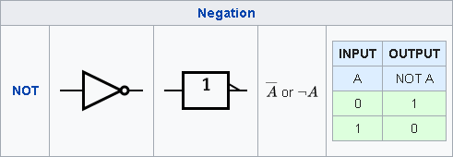

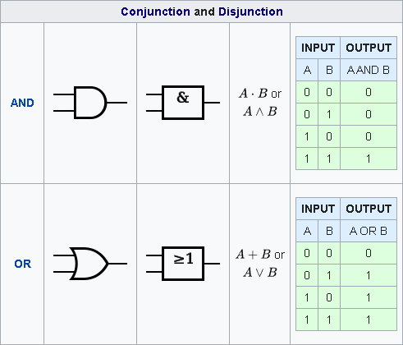

More info about logic gates can be found here.

We can build logic functions by "wiring together" such symbols:

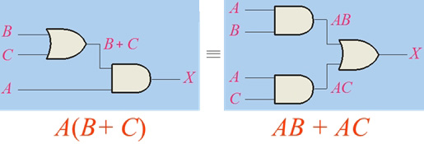

Each symbol corresponds to an electronic component, a so called "logic gate". Logic diagrams like this above model electronic circuits that implement some logic function . One could go to the shop, buy the logic gates and build the electronic circuit based on such circuit diagram.

Logic Simplification
OK, so now that we know about to counting rules, let's use them. When constructing logic circuits or even when writing a piece of software, it is desirable to express the logical relationship between the input signals, or input variables as simple as possible. Simplifying logic expressions saves computer power, energy, and ultimately money.

Simplification of logic expressions is achieved by applying the counting rules repeatedly, until the simple possible expression is obtained.

There are two problems here:
1) How we know in which order we should apply logical rules? ,and
2) How do we know that the expression at hand is the simplest possible one?

Well, we rely on our IQ, but when it comes to simplifying really huge expressions, our brain capacity may fall short. Therefore multiple systematic simplification techniques have been developed, that guarantee maximum simplification. These simplification techniques can even be converted into algorithms and programmed, so that computers can do the job for us.

Nevertheless, we'll go through some of the simplification techniques, just to find out how they work. We also learn how to add and multiply in elementary school, but at the end we prefer to use desktop calculators and computers to do actual arithmetics in everyday life.

We'll also learn how to simplify logical expressions by hand, so we can do that in a cave after World War III, and be able to restart civilization. ☺ More systematic methods include:

- Using Karnaugh diagrams
- Quine-McCluskey's tabular method

A good summary about mentioned methods can be found here.

Examples:

- Simplify the following logic expression: (A+B)(B+C).
(A+B)*(B+C)=
(A+B)*B+(A+B)*C= (distributive law)
A*B+B*B+A*C+B*C= (distributive law)
A*B+B+A*C+B*C= (idempotency B*B=B)
A*B+B*1+A*C+B*C= (identity B=B*1)
B*A+B*1+B*C+A*C= (commutability, applied twice)
B*(A+1+C)+A*C= (distributive law, applied backwards)
B*1+A*C= (annulment, applied twice)
B+A*C (identity, B*1=B)

- Simplify the following logic expression: (!A+B)(A+B).
(!A+B)(A+B)=
!A*A+!A*B+A*B+B*B=
0+(!A+A)*B+B=
B+B=
B.

Exercises:

Simplify the following logic expressions:
- A*!C+A*B*!C
- A*!B*C+A*!B*!C

Answers:

Combinatorial Networks
So by now we know, that:
- We can do arithmetics using numbers and arithmetic operators ( +,-,*,/ ).
For example: 3*4+2=14.
- We can do algebra by replacing numbers with letters, and thus express calculation rules more generally.
For example: Y=3*X+2
- And the new thing: We can express logic formally, using logical operators ( AND, OR, NOT ) together with logical calculation rules, the so called Boolean Algebra.
For example: Q = A AND B OR NOT C, which could also written as Q = A&B|!C.

We can also express logical relationships using:
- Textual expressions
- Truth tables
- Graphic symbols

In this section we'll speak a bit about combinatorial networks, which is nothing else than another fancy name for logical relationships. When we are using graphical symbols for logical operators, and interconnect them in order to form a logical relationship, it'll look as some kind of network, and it combines the input values to some output value, hence the name.

The following diagram represents a combinatorial network. It is also a logic function. Specifically, it implements the so called XOR (exclusive or) function.
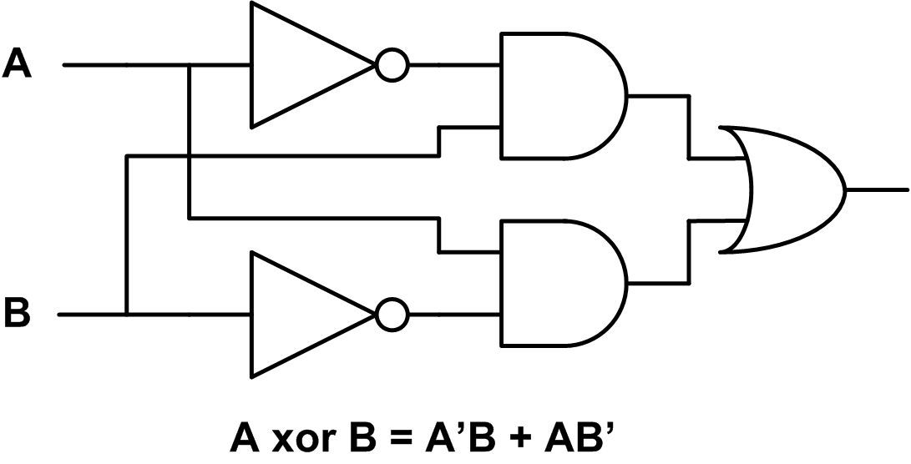

Figure 1 - Combinatorial Network

The corresponding truth table is:

A | B | !A*B+A*!B
0 | 0 | 0
0 | 1 | 1
1 | 0 | 1
1 | 1 | 0

Table 4 - Exclusive OR function

The XOR function is an extensively used function in digital circuit design. As we saw, it can be constructed from more basic components.

Other examples of frequently reused digital building blocks include:
- Encoders and decoders
- Multiplexers and demultiplexers
- Display drivers
- ..and more

We'll discuss the design of some useful logic circuits later on in the Designing Logic Circuits section below.

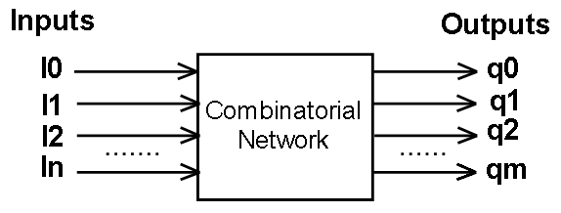
Figure 2 - Generic Combinatorial Network

OK, so if combinatorial networks is just another name to logic expressions, then what's the fuss?

Well, thinking about logical expressions as a form of combinatorial networks gives us the opportunity to generalize the thing, and will lead us to know how to build digital electronic circuits. Yeah, anything from simple blinkers to complex programmable devices, such as personal computers, or washing machine controllers ☺ .

Okay, so lets introduce the two most important generalizations:
- More than one output signal. A combinatorial network can have multiple output signals, not just a single one.
- Sequential Networks. The basic idea: "Some of the output signals we could feed back to the input." Now, this would create a situation where the output values of the network depends not just on the input values but also on the previous output values. This is a nifty thing, because it makes combinatorial networks have memory. They will remember their previous state, thus the new name sequential network.

Multiple output signals
The following diagram shows a combinatorial network with multiple outputs. If we wanted to represent the network below with Boolean expressions, then we could do this by writing multiple logic expressions, one expression for each output. The example circuit below realizes the following two boolean expressions:

SUM = ( A XOR B ) XOR CARRY_{IN}
CARRY_{OUT} = (A AND B ) OR ( (A XOR B) AND CARRY_{IN} )
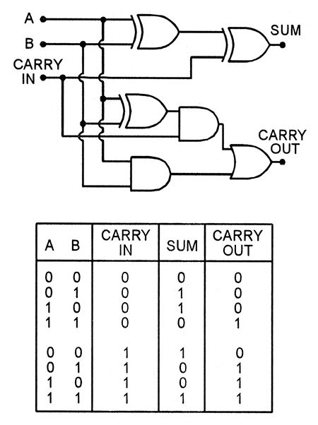
Figure 3 - Half Adder. A Circuit with two outputs.

Incidentally, the above circuit is called a half adder. It can be used to build networks that can arithmetically add two numbers. Later on, in the Designing Logic Circuits section, we'll see how the arithmetic operators +,-,*,/ can be implemented using boolean operators.

Sequential Networks
Imagine we have some combinatorial network with N inputs and M outputs, where N >=M. Now we take some of the outputs, say K outputs, where K <= M, and feed them back to the inputs. Something like this:

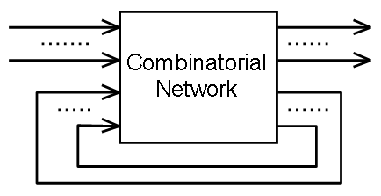
Figure 4 - Combinatorial Network with Feedback

This is the general setup for sequential networks, also called sequential logic.

Multivibrators
The absolute simplest 'combinatorial network' with feedback would be to take a single logic gate and feed its output back to the input.

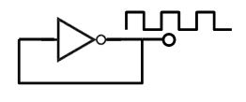
Figure 5 - Astable Multivibrator

In this example we used a NOT logic gate, also called an inverter. When the input signal is 0, the output signal is 1, which is fed back to the input, causing the output signal to invert to 0, which is fed back causing the output signal invert to 1, and so on. The circuit above will produce an output signal that constantly changes from 0 to 1 and back to 0.

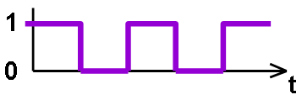
Figure 6 - Astable Multivibrator Output Signal

How often the changes between 0 to 1 and back to 0 occur?

If we assume that the NOT gate 'works instantly', that is, it takes no time to produce an output signal once an input signal is applied, then we can see the change frequency of the output signal would be infinite, that is we would get an output signal that is both 0 and 1 at the same time, which is impossible.

The mathematical model of the NOT gate ( NOT operator) does not consider any signal propagation delay, so our assumption based on the mathematical model was correct. However it leads to an impossible situation.

If we construct a NOT gate from electronic components, and try it, then we'll see that the output signal oscillates between 0 and 1 with a finite and measurable frequency. So what causes the output frequency to be finite?

Well, fact is, it is impossible to construct a NOT gate with zero propagation delay, so our mathematical model with zero propagation delay is somewhat inaccurate for practical purposes.

In reality, in each device, including the simplest logic gates, there has to be a signal carrier that carries data through the device and produces some output. If we use electricity, that is, if we construct electronic components to model the NOT operation, then the signal carrier will be electrons, which travel with a speed net to light speed in metals. (The speed of the free electrons is different in different metals, and it also depends on other factors, such as temperature.)

The finite speed of electrons causes a signal propagation delay. Once the input signal is applied, it will take some tome for the output to appear. That's great, since the result is an output signal in our multivibrator oscillating with a finite, measurable frequency. Said frequency is defined by the signal propagation delay within the NOT gate, that is the time it takes for the electrons to travel from the input to the output.

This thing is called a multivibrator. Any device that produces a continuous oscillating signal is a multivibrator. (Not to be confused with devices with similar name sold in shopping malls. ☺)

Unfortunately different instances of NOT gates produce different frequencies. Later on we'll see methods how to get 'desired' frequencies, rather than frequencies defined by the component-specific propagation delays.

We'll also construct more advanced sequential networks, including flip-flops (again, not to be confused with the similarly named footwear ☺) , memory cells, finite state machines, sequencers, and even a simple microprocessor. Building a simple microprocessor is the ultimate goal of this chapter about Digital Technology.

Once we know how computers are put together, in subsequent chapters we'll learn how to make them do what we want them to do. That is, we'll learn how to program them.

Clock Signal Generators
Clock signal generators are essentially astable multivibrators with a 'known' output frequency. Clock signals are used to make the behavior of sequential circuits predictable.

If we feed back some of the output signals to the input of a combinatorial network, then we get a so called asynchronous sequential circuit. The big problem with asynchronous sequential networks is that their behavior highly depends on the propagation delays of the logic gates, and those delays vary from one individual component to other.

In order to get rid of this problem, some smart guy thought that if we introduce a sufficiently high artificial delay in the feedback loop, then the natural delays will not matter anymore. So they put and AND gate in the way of the signals fed back to the inputs so that the free input of the AND gates are driven by a so called clock signal:

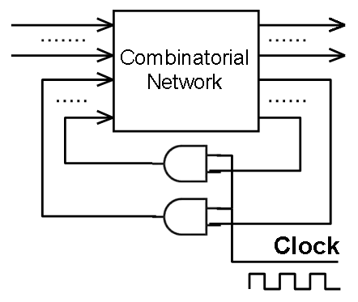
Figure 7 - Synchronous Sequential Circuit

The feedback signals can pass through the AND gates only when the other input of the AND gate, the clock signal input, is one (or high). Why? Because when the clock signal is low, then the output of the AND gate is low, but when the clock signal is high, then the output of the AND gate is the same as its other input. See the truth table of the AND gate.

In the above setup, the internal delays of the combinatorial network does not matter anymore, since the feedback loop is throttled by the clock signal, and the frequency of the clock signal is chosen to be much lower than the propagation delay caused by the components of the combinatorial network. This gives us network with predictable behavior, since the output signals will have plenty of time to settle between two clock cycles.

Sequential circuits that use clock signals are called synchronous sequential circuits.

Nowadays practically all digital circuits, including all computers are synchronous sequential circuits.

It's worth noting that synchronous circuits are much 'slower' than asynchronous circuits, but synchronous circuits are much easier to design and build. There are some applications where maximum processing speed is essential. There asynchronous circuits are used, because they are running at maximum speed, while the speed of synchronous circuits is defined by the clock frequency.

Flip-flops
The simplest sequential circuits are perhaps the so called flip-flops. Flip-flops are bi-stable devices. It means that their output is either 0 or 1. The desired output value can be set by applying an input signal.

Consider the following circuit:

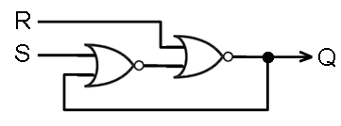
Figure 8 - Simple Set/Reset Flip-Flop

The two logic gates are NOR gates, with the following truth table:

A | B | !(A +B)
0 | 0 | 1
0 | 1 | 0
1 | 0 | 0
1 | 1 | 0
Table 5 - NOR Gate

Using the above truth table and the circuit diagram we can figure out the possible states of the circuit. That is to say, that we can figure out the Q output values for each combination of the input signals R (reset) and S (set).

The above circuit is asynchronous, because we do not have any clock signal. Instead, the Q output is fed back directly to the input. Thus we have three input signals, R, S, and Q_{t-1}, and a single output signal Q_{t}. Qt-1 signifies the previous value of Q, and Qt signifies the next value.

S | R | Q_{t-1} | Q_{t}
0 | 0 | 0 | 0
0 | 0 | 1 | 1
0 | 1 | 0 | 0
0 | 1 | 1 | 0
1 | 0 | 0 | 1
1 | 0 | 1 | 1
1 | 1 | 0 | 0
1 | 1 | 1 | 0

Table 6 - SR Flip Flop Truth Table

We have three input signals, which gives 2³=8 possible combinations of input signals. The corresponding boolean function is:

Q_{t}=!(R+!(S+Q_{t-1}))

RS Flip-Flop
Another, more symmetric looking coupling for the RS flip flop looks like this:

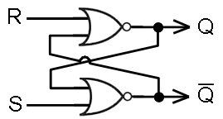
Figure 9 - RS Flip-flop
If we carefully compare with the coupling on the previous diagram, we can see that they are topologically equivalent. The only difference is that the outputs of both gates are used as outputs for the circuit.

Okay, so what's so great about this circuit?
It remembers its state. That is, one can store 1 bit worth of data in it. It is a 1-bit memory cell.

How is it used?
Normally both the Set and Reset inputs are low. When both inputs are low, the output Q is either low or high.

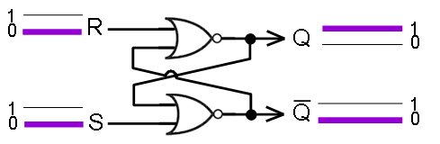
Figure 10 - RS Flip-flop holding 1 value

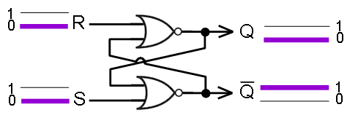
Figure 11 - RS Flip-flop holding 0 value

To set the Q output to high, raise the S input for a short time:

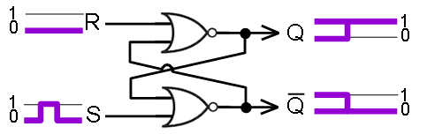
Figure 12 - Writing '1' into an RS flip-flop

To set the Q output to low, raise the R input for a short time:

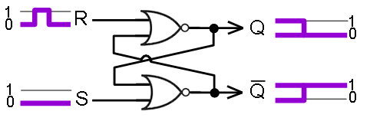
Figure 13 - Writing '0' into an RS flip-flop

The duration of the input pulse is not interesting as long as it is longer than the propagation delay of the circuit. The duration of the input pulse is also called pulse width. If the input pulse width is too short, then the output will become unpredictable. To overcome this we could convert the asynchronous RS flip-flop to a synchronous one by adding an additional clock input:
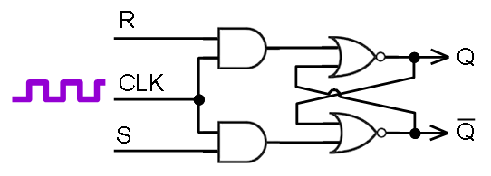
Figure 14 - Clocked RS flip-flop

The clock signal ensures that the output signals Q and !Q will change at predictable points in time, i.e. when CLK goes high.

If we were to build bigger circuits, containing multiple RS flip-flops and possibly other synchronous components, then we would feed the same clock signal to all of the components. This way we would assure that signals change at predictable points in time.

D Flip-Flop
The D flip-flop is a slightly modified RS flip-flop. It is specifically used to store one bit of data in it.
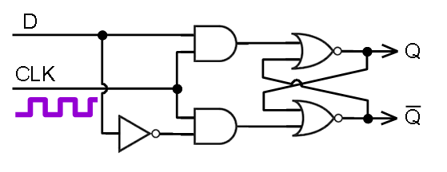
Figure 15 - D Flip-flop

The 'data' input is either '0' or '1' and it is written into the 'memory' whenever the CLK clock signal goes high.
Now if we were to build a useful memory cell, then the above circuit is not quite enough, because it unconditionally will store the D input value at each clock cycle. We need and additional 'write enable' signal, so that writing occurs only when the write enable signal is high. Adding this signal will give us a usable 1-bit memory cell.

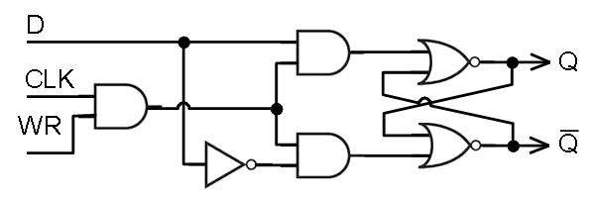
Figure 16 - 1-bit memory cell

The above circuit implements a 1-bit memory cell. Writing the value of the D (data) signal happens synchronously ( there is clock signal ), whenever the WR (write enable) signal goes high. The stored value can be read from the Q output.

Designing Logic Circuits
So far we covered the theoretical background required to construct logic circuits. Herein we'll see how to create logic circuits having increasing complexity. We start out with simple once, then we'll use them as building blocks to create more complex designs (, such as computers and other programmable devices ).

We'll treat combinatorial circuits first. As we might recall, combinatorial circuits are just a bunch of interconnected logic gates that feature a number of inputs and outputs. Each output function of a combinatorial circuit can be also written as a boolean expression, or it can be specified by listing the output values for each possible input value, that is, by writing a truth table.

Then we'll design some sequential circuits; a traffic light controller, among other things. Sequential circuits are combinatorial circuits for which some of their outputs are fed back to their inputs.

In most designs, the feedback signal is periodically switched on and off using a so called clock signal. This will slow down the circuit significantly, but it will make its output values predictable. We call these types of circuits synchronous sequential circuits.

If we omit the clock signal, and feed back the outputs directly to the inputs, then we get the fastest possible operation. Such circuits we call asynchronous sequential circuits. Such circuits are hard to construct in non-trivial cases. The main problem is that the output signals will become unpredictable, rendering the circuit useless. Nevertheless, there are techniques that ensure predictable operation for asynchronous circuits.

In our designs we'll use synchronous techniques only. Designing asynchronous circuits requires knowledge about electrical circuits as prerequisite, which we'll not cover herein.

Designing Combinatorial Logic
The overall design process for combinatorial logic goes like this:
- We define the number of inputs, and the number of outputs
- For all input combinations we specify the value of each output signal. We can express this using any combination of boolean expressions, truth tables, or circuit diagrams.
- We (usually) minimize the resulting logic, and express the minimal logic in disjunctive normal form (, an OR of ANDs, a sum of products).
- Optionally, we test the design using simulation software
- We implement the resulting boolean expressions using electronic logic gates or Programmable Logic Devices (PLDs).

Bringing Logic to a Minimal Disjunctive Normal Form
<tbd>

Implementation using integrated circuits containing discrete logic gates
<tbd>

Implementation using persistent memory devices
<tbd>

Implementation using programmable logic devices
<tbd>

Applications of Combinatorial Logic
One obvious application of combinatorial logic is to build sequential logic. Each sequential logic circuit has at least one combinatorial logic component.

Pure combinatorial logic has three main applications. It is used to implement:

- Data Transmission
- Multiplexers, demultiplexers, encoders, decoders
- Code converters for input and output devices
- Binary, 7-segment, and BCD display drivers
- Keyboard input matrices
- Pointing devices ( mice and touchpads )
- Arithmetic functions
- Comparators, adders, subtractors, programmable logic devices

In the rest of this section we'll go through some design examples of increasing complexity.

Multiplexers
A multiplexer is a circuit that allows you to select one of many inputs as output. The output mirrors the selected input, so when the selected input is 0 the output is 0, when it is 1 the output is 1. It is commonly used as a building block to combine multiple input signals into a single output signal. Multiplexers are often depicted using symbols similar to this:

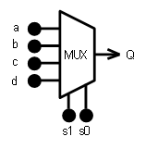
Figure 17 - 4 to 1 Multiplexer

The figure above shows a 4-to-1 multiplexer, with 4 data inputs, a, b, c, and d, and one output Q. The selector inputs are s₁ and s₀. The combined value of s₁s₀ can be any of 00, 01, 10, and 11. When s₁s₀=00, then Q=a, when s₁s₀=01, then Q=b, when s₁s₀=10, then Q=c, and when s₁s₀=11, then Q=d.

We can easily build the truth table of the 4-to-1 multiplexer. Since we have 6 inputs a, b, c, d, s₁, and s₀, the number of rows in the truth table will be 2⁶=64. That's a lot to write. To illustrate the problem, here are the first 32 rows of the complete truth table:

s₁ | s₀ | a | b | c | d | Q
0 | 0 | 0 | 0 | 0 | 0 | 0
0 | 0 | 0 | 0 | 0 | 1 | 0
0 | 0 | 0 | 0 | 1 | 0 | 0
0 | 0 | 0 | 0 | 1 | 1 | 0
0 | 0 | 0 | 1 | 0 | 0 | 0
0 | 0 | 0 | 1 | 0 | 1 | 0
0 | 0 | 0 | 1 | 1 | 0 | 0
0 | 0 | 0 | 1 | 1 | 1 | 0
0 | 0 | 1 | 0 | 0 | 0 | 1
0 | 0 | 1 | 0 | 0 | 1 | 1
0 | 0 | 1 | 0 | 1 | 0 | 1
0 | 0 | 1 | 0 | 1 | 1 | 1
0 | 0 | 1 | 1 | 0 | 0 | 1
0 | 0 | 1 | 1 | 0 | 1 | 1
0 | 0 | 1 | 1 | 1 | 0 | 1
0 | 0 | 1 | 1 | 1 | 1 | 1
0 | 1 | 0 | 0 | 0 | 0 | 0
0 | 1 | 0 | 0 | 0 | 1 | 0
0 | 1 | 0 | 0 | 1 | 0 | 0
0 | 1 | 0 | 0 | 1 | 1 | 0
0 | 1 | 0 | 1 | 0 | 0 | 1
0 | 1 | 0 | 1 | 0 | 1 | 1
0 | 1 | 0 | 1 | 1 | 0 | 1
0 | 1 | 0 | 1 | 1 | 1 | 1
0 | 1 | 1 | 0 | 0 | 0 | 0
0 | 1 | 1 | 0 | 0 | 1 | 0
0 | 1 | 1 | 0 | 1 | 0 | 0
0 | 1 | 1 | 0 | 1 | 1 | 0
0 | 1 | 1 | 1 | 0 | 0 | 1
0 | 1 | 1 | 1 | 0 | 1 | 1
0 | 1 | 1 | 1 | 1 | 0 | 1
0 | 1 | 1 | 1 | 1 | 1 | 1
…
Figure 18 - 4-to-1 multiplexer truth table

We see in the above truth table that when s1s0=00, then Q=a, and the values of the remaining inputs don't matter. When s1s0=01, then Q=b, and so on. Instead of writing pagefuls of zeroes and ones, we can represent this in a much more compact way:

s₁ | s₀ | Q_{t}
0 | 0 | a
0 | 1 | b
1 | 0 | c
1 | 1 | d
Figure 19 - 4-to-1 multiplexer truth table

One possible way to build a 4-to-1 multiplexer circuit out of logic gates would be like this:

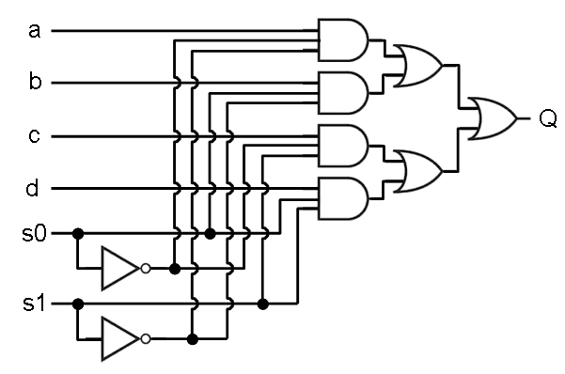
Figure 20 - 4-to-1 multiplexer circuit diagram

Sometimes we need bigger multiplexers, such as 8-to-1 or even 64-to-1 multiplexers. Fortunately we don't need to redesign them over and over again. Instead we use the
'multiplexer' logic symbol in our circuit designs. We can do this, because multiplexers are readily available to buy as a single integrated circuit (IC).

Demultiplexers
<tbd>

Encoders
<tbd>

Decoders
<tbd>

Comparators
<tbd>

Adders
<tbd>

Designing Sequential Logic
The crucial difference between combinatorial logic and sequential logic is the presence of signal feedback. Sequential circuits can have any number of internal states. The internal states and the transitions between internal states is conveniently represented by so called transition diagrams (potato diagrams). Sequential logic circuits with a finite number of states are called finite state automatons (FSA). When we draw a potato diagram, we effectively design an FSA.

The first step in designing sequential circuits is to define the FSA. Then we choose an encoding based on the FSA. Based on the chosen encoding we can define the combinatorial logic for the FSA, and also the feedback signals.

Finite State Automatons
<tbd>

Encoding of internal states
<tbd>

Applications of Sequential Logic
Sequential logic has a wide range of applications. Most consumer products, industrial equipment and military applications that make use of digital technology contain synchronous sequential logic. Sequential logic is used for implementing:

- Device controllers
- computer input, output and storage devices ( keyboard controllers, mouse controllers, hard disk drives, display adapters, network communication adapters,..)
- embedded applications ( for example, traffic light controllers, the controller of a fuel dispenser, a washing machine, the servo system in an airplane, a self propelled missile, and more )
- Computer components
- Memory devices (RAM, ROM, SSD )
- Instruction processing units (CPU)
- Arithmetic and Logic units ( ALU)
- Sequencers
- Graphical display controllers
- Controllers for other computer peripheral devices ( i.e. devices that you connect to computers)
- Communication bus arbiters ( for e.g. USB, Ethernet, HDMI, PS2 and other data buses )

In the rest of this section we'll go through some design examples of increasing complexity.

Basic Building Blocks

The JK Flip-Flop.
The JK flip-flop is an improved version of the RS flip-flop. The main difference is that when both inputs are high, the state of the RS flip-flow becomes inconsistent: both Q and !Q become 0. To overcome this problem, we'll make a slight modification, as shown below:

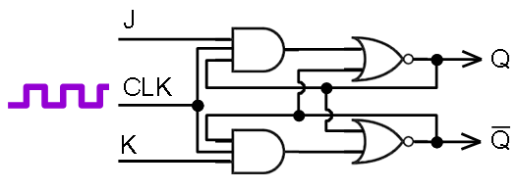
Figure 21 - JK Flip-flop

Now, when both inputs (J and K ) are high, the value on the Q output is toggled ( reversed ).

S | R | Q_{t-1} | Q_{t}
0 | 0 | 0 | 0
0 | 0 | 1 | 1
0 | 1 | 0 | 0
0 | 1 | 1 | 0
1 | 0 | 0 | 1
1 | 0 | 1 | 1
1 | 1 | 0 | 1
1 | 1 | 1 | 0
Table 7 - JK Flip FLop Truth Table

When we assemble digital circuits from simpler ones, we use to represent the component circuits simply by single symbol. For example, the following symbols can be used to represent flip flops:
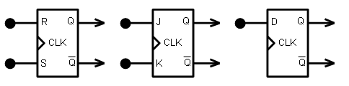
Figure 22 - Flip Flop Symbols

The Toggle Flip Flop
The toggle flip flop is a type of flip-flop for which the input signal T will toggle (reverse) the value of the output signal. That is, sending a pulse to the T input when the output Q is low, then the output will switch to high, and vice versa, sending a pulse to the T input when the output Q is high, then the output will switch to low.

T | Q_{t-1} | Q_{t}
0 | 0 | 0
0 | 1 | 1
1 | 0 | 1
1 | 1 | 0
Table 8 - T Flip Flop Truth Table

We saw previously how to create a Data flip-flip (D flip-flop), by combining an RS flip-flop with a NOT gate.

Similarly we could produce a so called T flip-flop from either a JK flip-flop or a D flip-flop:

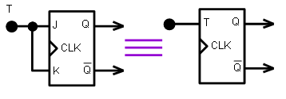
Figure 23 – Synchronous T Flip-Flop made from JK Flip-Flop

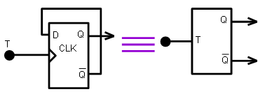
Figure 24 - Asynchronous T Flip-Flop made from D Flip-flop

Master-slave RS Flip-Flop
Master-slave flip-flops can be constructed by using two flip-flops and coupling them in cascade. Why on earth should we do that?

Well, because simple flip-flops have some undesirable shortcomings we try to improve. The basic idea of RS flip-flops is nice, but the output is uncertain when both the R and S inputs are high. Therefore JK flip-flops were invented, for which the output is more predictable when both inputs are high. Namely, the output will toggle.

We also introduced a clock signal in order to make sure our digital circuits have enough time to reach a stable state. Fine. However a problem still remains: When the clock signal is high, and both inputs of the JK flip-flop are high, then the output will keep toggling, rendering the final output unpredictable. The actual output will depend on the pulse with of the clock signal. This can give real headaches if we constructed some digital circuit that works fine, but later we decide to make it faster and higher the clock signal frequency. We used to say, that ordinary flip-flops are transparent when the clock signal is high. That means, that when the clock signal is high, the input signal passes the circuit and produces an output signal. Now, if the output signal is fed back, then it can lead to an instable state, resulting in an oscillating output signal. The output signal will stabilize at the moment the clock signal goes low, at the end of the clock pulse. This is an undesirable condition. We do not want the behavior of our circuits we construct to depend on the clock frequency or on the clock pulse width. In order to overcome this, master-slave flip-flops were invented. They look like this:

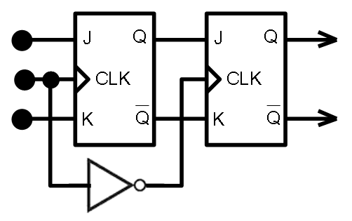
Figure 25 - Master-Slave JK Flip-Flop

The master-slave flip-flop is no longer transparent since when the input clock signal is high, the clock signal of the second flip-flop is low. Thus the output remains stable. Also, when the input clock signal is low, the clock signal to the second (slave) flip-flop is high though, but this is not a problem in this case, since the J and K inputs of the slave are not both high, so the output is again stable. Great. The above construction is a very usual flip-flop construction.

We can illustrate the workings of digital circuits using timing diagrams. The following timing diagram illustrates the working of a JK flip-flop, when the flip-flop is set (, as opposed to reset):
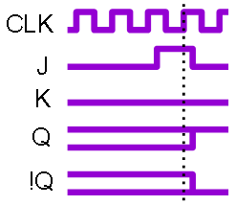
Figure 26 - SET Operation for a JK flip-flop

In the above diagram, imagine time flows from left to right. The clock signal CLK goes low and high periodically. At some point in time the flip-flop is set, by raising the J input while the K input remains low. The change on the output will occur as soon as the CLK goes high. The dotted line shows the point in time when the clock signal goes high for the first time after the input signal changed. Because signal propagation takes time, there is a slight delay between the time the clock signal goes high and the outputs Q and !Q actually change.

We said, that the JK flip-flop (the best flip-flop we have so far ) is still not perfect, because the output may oscillate while all three input signals, the clock signal, the J input and the K input are all high. The corresponding timing diagram that illustrates this condition would look like this:

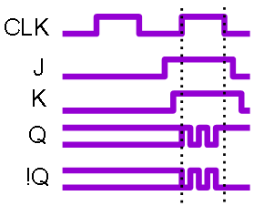
Figure 27 - Oscillating outputs of JK flip-flops

Now one could argue, that having both the J and K input signals high simultaneously is not a 'normal' condition, therefore it is unnecessary to account for it. Normally we either set J, or K, or none of them, but never both J and K at the same time. Well, as a designer, we might make sure this condition never occurs, but in practice this is actually very hard to achieve because of transient (temporary) conditions caused by signal propagation delays. It is way better to make sure that all possible input combinations produce a predictable output.

The master-slave construction solves the problem indeed. First let's see how a master-slave JK flip-flop behaves when applying a set input command, that is, when J is high and K is low:

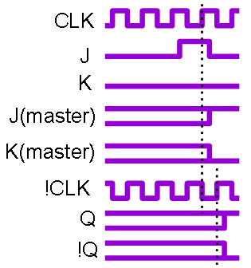
Figure 28 - SET Operation for a master-slave JK flip-flop

As we can see, it behaves exactly as a simple JK flip-flop: When the J input signal is raised, the Q output will raise at the next clock pulse. However there is a difference in the delay between the signal input and the time when the output is actually set: In a simple JK flip-flop, the output is set at the raising edge of the clock pulse, while in a master-slave JK flip-flop, the output is set at the falling edge of the clock pulse. This means, the output is set a half clock pulse period later in master-slave flip-flops then in simple flip-flops, making master-slave flip-flops slower than simple flip-flops.

Now let's see what happens, when all input signals J, K, and CLK are simultaneously high. Will the output oscillate? (no)

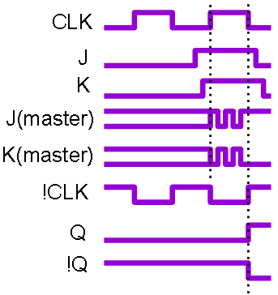
Figure 29 – The outputs of master-slave JK flip-flops never oscillate

The outputs of the master-slave JK flip-flop will not oscillate. Instead they will be set at the falling edge of the clock pulse to a stable state. We used to say, that when the output oscillate, then we have an instable state, or racing condition.

Conclusion: The master-slave JK flip-flop is the perfect flip-flop since its outputs are predictable for all possible input signal combinations.

Unfortunately it is also the slowest construction. It takes a half of clock period for the outputs of a master-slave flip-flop to set. For simple flip-flops the output is set directly after the first rising edge of the clock signal. Fastest are the asynchronous flip-flops ( those without a clock signal at all ), because there is no clock signal to wait for. The output signal is delayed only by the physical signal propagation delay.

How often can the output signal change?
For synchronous flip-flops, master-slave or not, the output signal can change once within each clock period.
For asynchronous flip-flops, the change frequency is theoretically unlimited, however, in practice it is limited by the physical propagation delay. The maximal change frequency should be lower than 1/(maximum propagation delay).

Advanced building blocks
So far we've developed a nice building block, the master-slave JK flip-flop. We'll use this component to produce some more advanced building blocks.

Binary Counter
A binary counter counts incoming pulses. The output represents a binary number corresponding the number of incoming pulses.

How long a counter can count, depends on the number of bits stored. For example a 2-bit counter can count to 3 ( 0,1,2,3 ), because it has two stored bits, and the total number of states that can be represented in to bits is 2²=4. A 4-bit counter can count to 15, and an n-bit counter can count to 2^{n-1} since n bits can represent 2^{n} states.

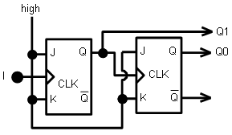
Figure 30 - 2-bit Binary Counter

The above figure shows a 2-bit binary counter made up of two synchronous JK flip-flops. The pulses to be counted go into the CLK input of the first flip-flop, and the Q output of the first flip-flop drives the second flip-flop. The outputs of both flip-flops are taken to represent a binary value corresponding to the pulse count.

The output signals Q0 and Q1 change for every rising edge of the input pulse I, as shown in the following timing diagram:

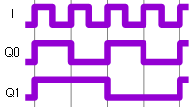
Figure 31 - 2-bit Counter Timing Diagram

The circuit above is a modulo 4 counter. It has four states, Q₀Q₁=00, Q₀Q₁=01, Q₀Q₁=10, and Q₀Q₁=11. For each raising edge of the incoming pulse, the counter will change state, as shown in the state diagram below:

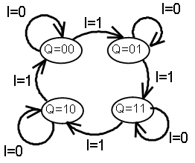
Figure 32 - 2-bit Counter State Diagram

The state diagram above shows, that when the input signal I=0, no state transition occurs. When I=1, and we are in state Q=00, then a state transition occurs to state Q=01, and so on. If we interpret the output signal Q=Q₁Q₀ as a binary number, we get a binary counter having this state diagram:

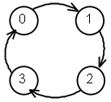
Figure 33 - modulo 4 counting

We can define the same behavior using a truth table as well:

I | Q_{1@t-1} | Q_{0@t-1} | Q_{1@t} | Q_{0@t}
0 | 0 | 0 | 0 | 0
1 | 0 | 0 | 0 | 1
0 | 0 | 1 | 0 | 1
1 | 0 | 1 | 1 | 0
0 | 1 | 0 | 1 | 0
1 | 1 | 0 | 1 | 1
0 | 1 | 1 | 1 | 1
1 | 1 | 1 | 0 | 0

Table 9 - 2-bit binary counter truth table

Decimal Counter
Now having digital circuits being able to count until 3 is nice, but what if we would like to count until 9 at least? If we had a counter that were able to count to 9, then we could use multiple such counters, one for each decimal digit, to count to any desired maximum number. OK, so let's build a counter with 10 states (0,1,2,3,4,5,6,7,8,9).

By adding one more flip-flop to the binary counter above, we could count to 2³-1=7, which is less than 9, so it not enough.

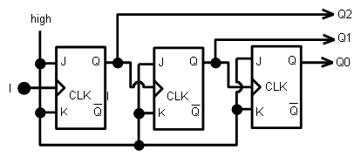
Figure 34 - 3-bit Binary Counter

By adding yet one more flip-flop, we get a 4-bit counter, which counts to 2⁴-1=15, which is too much.
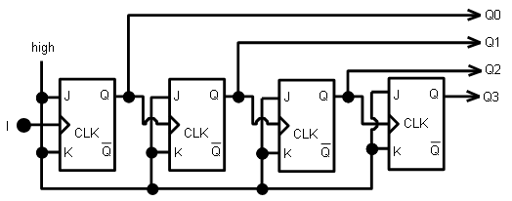
Figure 35 - 4-bit Binary Counter

What we want is a counter that has 10 states, 0,1,2,3,4,5,6,7,8,9:

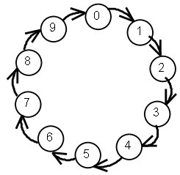
Figure 36- decimal counter state diagram

When our 4-bit binary counter reaches state "10", we'll send the circuit to state "0". This way we'll get a decimal counter. The binary representation of number 10_{d} is 1010_{b} , so whenever the output is 1010_{b}, well reset bits 1 and 3 so that it becomes 0000_{b} . We can do this by adding a NAND gate like this:

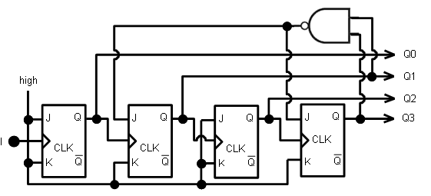
Figure 37 - Decimal Counter

The decimal counter above will periodically count from 0000_{b} to 1001_{b}, that is from 0_{d} to 9_{d}.

Two-digit Decimal Counter
In this small project we'll use the decimal counter above to build a two-digit counter that can count from 00 to 99. We'll also add two so called 7-segment numerical displays, one for each digit, to display the output of our two-digit counter.

First, for the same of simplicity, let's represent the decimal counter above with this symbol:

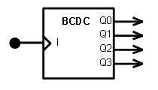
Figure 38 - 1-digit BCD Counter

BCDC stands for Binary Coded Decimal Counter. As it's name suggests, the output vector Q=[Q3,Q2,Q1,Q0] represents a binary encoded value.

We could display this value by simply attaching four lamps to Q3, Q2, Q1, and Q0 respectively that are lit when the output signal is high. That would visualize the binary representation of the digit, but most people find it hard to read binary numbers.

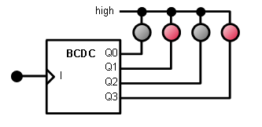
Figure 39 - Visualizing the output using lamps

Instead, we would lie to see the number displayed as an arabic number, which we are used to read. Something like this:

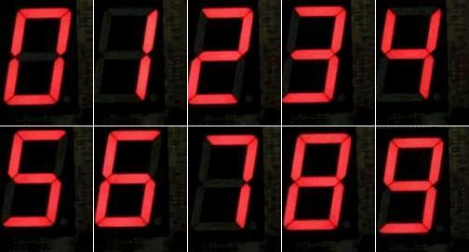
Figure 40 - 7-segment display output

We can see that the shapes of all decimal digits can be constructed using seven stick-like segments. 7-segment displays are readily available as electronic components. They contain 7 lamps ( light emitting diodes ) arranged in a specific pattern, so that they can be used to display any decimal digit between 0 and 9. In a schematic design diagram, a 7-segment display is represented by symbols similar to this:

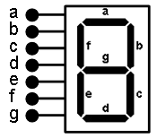
Figure 41 - 7-sement display

Now we have a problem: Our BCD counter has four output signals Q0, Q1, Q2, Q3, which represents a value between 0 and 9, but the display device has 7 inputs. The display device expects a different encoding than our BCD counter produces. So what we do?

We'll construct a combinatorial network that converts binary encoded numbers to a format suitable for driving the 7-segment display with. Such a device is called a 7-segment decoder.

Let's see how the digits 0,1,2,3,4,5,6,7,8, and 9 are represented in binary and in 7-segment formats:

For digit 0, the inputs a, b, c, d, e and f need to be on, and g needs to be off. (See figure above.)
For digit 1, b is on, c is on, and the rest of the segments are off.
For digit 2, a, b, g, e and d are on.
and so on…

The following table specifies the segment values for all 10 digits:

# | Q₃ | Q₂ | Q₁ | Q₀ | a | b | c | d | e | f | g
0 | 0 | 0 | 0 | 0 | 1 | 1 | 1 | 1 | 1 | 1 | 0
1 | 0 | 0 | 0 | 1 | 0 | 1 | 1 | 0 | 0 | 0 | 0
2 | 0 | 0 | 1 | 0 | 1 | 1 | 0 | 1 | 1 | 0 | 1
3 | 0 | 0 | 1 | 1 | 1 | 1 | 1 | 1 | 0 | 0 | 1
4 | 0 | 1 | 0 | 0 | 0 | 1 | 1 | 0 | 0 | 1 | 1
5 | 0 | 1 | 0 | 1 | 1 | 0 | 1 | 1 | 0 | 1 | 1
6 | 0 | 1 | 1 | 0 | 1 | 0 | 1 | 1 | 1 | 1 | 1
7 | 0 | 1 | 1 | 1 | 1 | 1 | 1 | 0 | 0 | 0 | 0
8 | 1 | 0 | 0 | 0 | 1 | 1 | 1 | 1 | 1 | 1 | 1
9 | 1 | 0 | 0 | 1 | 1 | 1 | 1 | 0 | 0 | 1 | 1
Figure 42 - 7-segment decoder truth table

Based on the table above truth table we can now create our BCD to 7-segment decoder.

Can you write down the seven boolean expressions for the outputs a, b, c, d, e, f, and g?

Is it possible to simplify any of the seven expressions, so that we minimize the number of logical gats used?

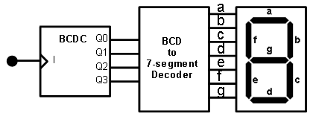
Figure 43 - single digit BCD counter with display

The above counter can count from 0 to 9. Now how to make a two digit counter that counts from 00 to 99?

We observe, that in decimal numbers, when a digit at a certain position wraps around from 9 to 0, then the digit on the next higher position gets incremented by one. For example, when we count from 19 to 20, then the digit in position 0 wraps from 9 to 0 and the digit in position 1 gets incremented by one.
1₁9₀ -> 2₁0₀

This means, that we can use one BCD counter for each digit in a multi-digit number and increment the counter in the higher position whenever the counter value on the lower position becomes 0. All we need is a bunch of BCD counters and some AND gates to detect zero values:

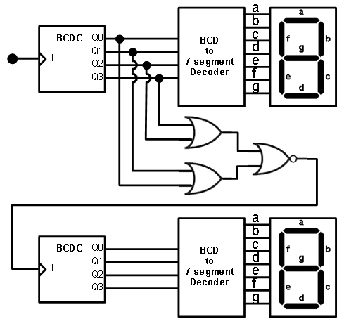
Figure 44 - 2-digit BCD Counter

Real-world embedded design examples

Traffic Light Controller
<tbd>

Elevator Controller
<tbd>

Building a Simple Computer

Bit Register
<tbd>

Random Access Memory (RAM)
<tbd>

Arithmetic Logic Unit (ALU)
<tbd>

Simple Central Processing Unit
<tbd>

Memory Controller
<tbd>

Keyboard Controller
<tbd>

Magnetic Hard Disk Controller
<tbd>

Display Controller
<tbd>

Simple Bus Arbiter
<tbd>

Simple Network Adapter
<tbd>

Putting it all together – the complete computer design
<tbd>

Using Specialized Peripherals
<tbd>

Peripherals for industrial applications
AD converters
Step motor controllers
Temperature, pressure, humidity sensors
Presence and motion sensors
Complex sensors: microphones, cameras, airplane black boxes

Special peripherals within a mobile phone
Telephone network adapters
Bluetooth, NFC, USB adapters
Memory card adapters
Speaker
Microphone
Camera
Touch screen
Accelerometer
GPS receiver
Orientation detector
Fingerprint sensor

Special peripherals for mobile agents
IMU
GPS
LIDAR

Programming concepts
We’ll consider the von Neumann model of computing. Most existing digital computers follow this model (, but not all; more on that later.) Neumann came up with this model around 1945, while waiting for the bus, according to the anecdote. By that time computer programs were hardwired. That is, in order to modify the computer program one needed to modify the hardware of the computer. When some colleague of Neumann complained how hard it is to reprogram computers, Neumann just said: Well, just store programs as data.

This fundamental idea, storing programs as data, gave birth to modern digital computers as we know them today.

According to this model of computing, a computer has a Central Processing Unit (CPU), it has memory, input and output (IO) interfaces.

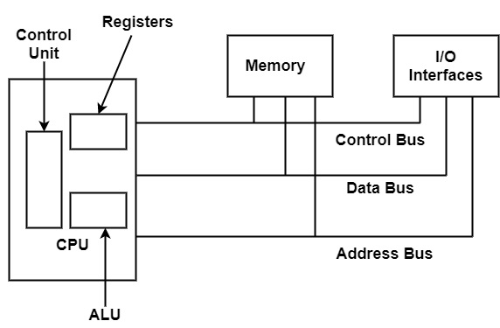
Figure 45 - von Neumann model of a digital computer

A simple von Neumann computer works by reading instructions to execute from the memory, one at a time, executes the instruction, then reads the next instruction.

Computer instructions operate on data. The data they operate on are also stored in memory. There are instruction for reading and writing the memory, reading and writing the IO ports (interfaces), to perform arithmetic and logical operations, and more. We’ll study CPU instruction sets in more detail in the sections that follow.

Keyboards, mice, printers, hard drives (secondary storage), network cards, display adapter cards, and other devices are attached to the IO interfaces. Some of these devices provide data input (such as the mouse, or the keyboard), others are used for output (printers, display screens), and yet others can perform both input and output operations. Network adapter cards make data exchange possible with other computers. Network adapter cards perform both input and output operations. Secondary storage devices (e.g. hard disks) can also be read or written.

Before we talk about programming, first we’ll examine the general architecture of classic computer hardware in the next section. Then we’ll look at some real-word processors, their instruction sets, and learn how to program them using assembly language.

Computer Architecture
According to the von Neumann model a computer consists of a Central Processing Unit (CPU), Random Access Memory (RAM), and IO ports. These components are interconnected with a bunch of wires we call Buses. Input and Output devices can be connected to the IO ports. This is a very simplistic description of any computer. In reality there are more details to it, which will consider below with gradually increasing detail.

Central Processing Unit

Random Access Memory
<>

Buses
<>

IO Ports
<>

Peripheral Devices

The keyboard
<>

The Display Adapter
<>

The Network Adapter
<>

Storage Devices
<>

Programming the 6502 microprocessor

Programming the 8086 microprocessor

This may however change. Artificial intelligence and machine learning in particular is evolving at an accelerating pace, making in possible for computers to actually understand data, and evolve from mere data processors to information processors.

